CHAPTER-1
INTRODUCTION
1.1 Electric Discharge Machine
1.1.1 Introduction

A machining process, where electrical energy is used to generate electrical spark and material removal mainly occurs due to thermal energy of the spark. Material is removed from the work piece through localized melting and vaporization of material. Electric sparks are generated between two electrodes when the electrodes are held at a small distance from each other in a dielectric medium and a high potential difference is applied across them. Localized regions of high temperatures are formed due to the sparks occurring between the two electrode surfaces. Work piece material in this localized zone melts and vaporizes. Most of the molten and vaporized material is carried away from the inter-electrode gap by the dielectric flow in the form of debris particles.
To prevent excessive heating, electric power is supplied in the form of short pulses. Spark occurs wherever the gap between the tool and the work piece surface is
smallest. After material is removed due to a spark, this gap increases and the location of the next spark shifts to a different point on the work piece surface. In this way several sparks occur at various locations over the entire surface of the work piece corresponding to the work piece-tool gap. Because of the material removal due to sparks, after some time a uniform gap distance is formed throughout the gap between the tool and the work piece. Thus, a replica of the tool surface shape is formed on the work piece as shown in Figure-1.
If the tool is held stationary, machining would stop at this stage. However if the tool is fed continuously towards the work piece then the process is repeated and more material is removed. The tool is fed until the required depth of cut is achieved. Finally, a cavity corresponding to replica of the tool shape is formed on the work piece.
TOOL (−)
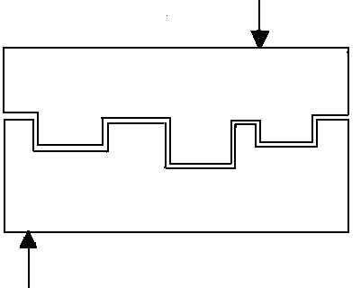
WORK-PIECE (+)
Fig-1.1 shows the cavity corresponding to replica of the tool shape is formed on the work piece.

EDM is mainly used to machine difficult-to-machine materials and high strength temperature resistant alloys. EDM can be used to machine difficult geometries in small batches or even on job-shop basis. Work material to be machined by EDM has to be electrically conductive. Fuelled by a growing need for high strength materials in technologically advanced industries and supported by the advances in the field of material science, there has been an increase in the availability and use of difficult-to-machine materials. Nontraditional machining processes are necessary for machining of such materials. Electrical Discharge Machining (EDM) is one such process which is widely used to machine electrically conductive materials. EDM is a thermo-electric process in which material removal takes place through the process of controlled spark generation. It is one of the most popular non-traditional machining processes being used today in the industry. EDM is commonly used in mould and die making industry and in manufacturing automotive, aerospace and surgical components.
Since there is no mechanical contact between the tool and the work piece, thin and fragile components can be machined without the risk of damage. EDM has achieved a status of being nearly indispensable in the industry because of its ability to machine any electrically conductive material irrespective of its mechanical strength.
1.1.2 Process

In EDM, a potential difference is applied between the tool and work piece. Both the tool and the work material are to be conductors of electricity. The tool and the work material are immersed in a dielectric medium. Generally kerosene or deionised water is used as the dielectric medium. A gap is maintained between the tool and the work piece. Depending upon the applied potential difference and the gap between the tool and work piece, an electric field would be established. Generally the tool is connected to the negative terminal of the generator and the work piece is connected to positive terminal.

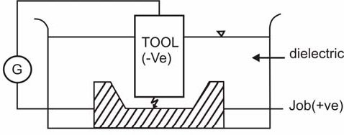

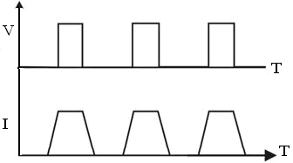
Fig-1.2 shows schematically the basic working principle of EDM process.

As the electric field is established between the tool and the job, the free electrons on the tool are subjected to electrostatic forces. If the work function or the bonding energy of the electrons is less, electrons would be emitted from the tool (assuming it to be connected to the negative terminal). Such emission of electrons are called or termed as cold emission. The “cold emitted” electrons are then accelerated towards the job through the dielectric medium. As they gain velocity and energy, and start moving towards the job, there would be collisions between the electrons and dielectric molecules. Such collision may result in ionizations of the dielectric molecule depending upon the work function or ionization energy of the dielectric molecule and the energy of the electron. Thus, as the electrons get accelerated, more positive ions and electrons would get generated due to collisions. This cyclic process would increase the concentration of electrons and ions in the dielectric medium between the tool and the job at the spark gap. The concentration would be so high that the matter existing in that channel could be characterized as “plasma”. The electrical resistance of such plasma channel would be very less. Thus all of a sudden, a large number of electrons will flow from the tool to the job and ions from the job to the tool. This is called avalanche motion of electrons. Such movement of electrons and ions can be visually seen as a spark. Thus the electrical energy is dissipated as the thermal energy of the spark.
The high speed electrons then impinge on the job and ions on the tool. The kinetic energy of the electrons and ions on impact with the surface of the job and tool respectively would be converted into thermal energy or heat flux. Such intense localized heat flux leads to extreme instantaneous confined rise in temperature which would be in excess of 10,000ºC. Such localized extreme rise in temperature leads to material removal. Material removal occurs due to instant vaporization of the material as well as due to melting. The molten metal is not removed completely but only partially.
As the potential difference is withdrawn as shown in Fig. 1, the plasma channel is no longer sustained. As the plasma channel collapse, it generates pressure or shock waves, which evacuates the molten material forming a crater of removed material around the site of the spark. Thus to summarize, the material removal in EDM mainly occurs due to formation of shock waves as the plasma channel collapse owing to discontinuation of applied potential difference.

DC Power Supply
(+)
Positive
(−)
Negative
Fixture
Work Piece
Electrode Gap
Dielectric Fluid

Electrode
Servo Motor

Fig-1.2 shows the different parts of Die-Sinking EDM Machine.

Generally the work piece is made positive and the tool negative. Hence, the electrons strike the job leading to crater formation due to high temperature and melting and material removal. Similarly, the positive ions impinge on the tool leading to tool wear. In EDM, the generator is used to apply voltage pulses between the tool and the job.
A constant voltage is not applied. Only sparking is desired in EDM rather than arcing. Arcing leads to localized material removal at a particular point whereas sparks get distributed all over the tool surface leading to uniformly distributed material removal under the tool.
1.1.3 Process Parameters
The process parameters in EDM are mainly related to the waveform characteristics.
Fig. 2 shows a general waveform used in EDM.
The waveform is characterized by the -:
- The open circuit voltage - V_{o}
- The working voltage - V_{w}
- The maximum current - I_{o}
- The pulse on time – the duration in which spark is generated- T_{on}
- The pulse off time - T_{off}
- The gap between the work piece and the tool – spark gap - δ
- The polarity – straight polarity – tool (-v_{e})
- The dielectric medium
- External flushing through the spark gap.
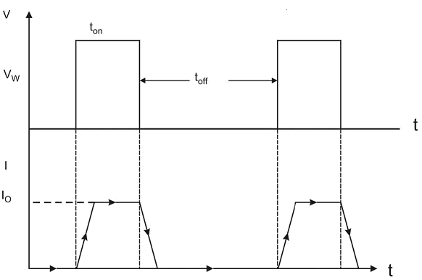
Fig-1.4 shows the square pulse form of EDM machine.

1.1.4 Characteristics of EDM
(a) The process can be used to machine any work material if it is electrically conductive.
(b) Material removal depends on mainly thermal properties of the work material rather than its strength, hardness etc.
(c) In EDM there is a physical tool and geometry of the tool is the positive impression of the hole or geometric feature machined.
(d) The tool has to be electrically conductive as well. The tool wear once again depends on the thermal properties of the tool material.
(e) Though the local temperature rise is rather high, still due to very small pulse on time, there is not enough time for the heat to diffuse and thus almost no increase in bulk temperature takes place. Thus the heat affected zone is limited to 2–4 μm of the spark crater.
(f) However rapid heating and cooling and local high temperature leads to surface hardening which may be desirable in some applications (g)Though there is a possibility of taper cut and over cut in EDM, they can be controlled and compensated.
1.1.5 Dielectric

In EDM, as has been discussed earlier, material removal mainly occurs due to thermal evaporation and melting. As thermal processing is required to be carried out in absence of oxygen so that the process can be controlled and oxidation avoided. Oxidation often leads to poor surface conductivity (electrical) of the work piece hindering further machining. Hence, dielectric fluid should provide an oxygen free machining environment. Further it should have enough strong dielectric resistance so that it does not breakdown electrically too easily but at the same time ionize when electrons collide with its molecule. Moreover, during sparking it should be thermally resistant as well.
Generally kerosene and deionised water is used as dielectric fluid in EDM. Tap water cannot be used as it ionizes too early and thus breakdown due to presence of salts as impurities occur. Dielectric medium is generally flushed around the spark zone. It is also applied through the tool to achieve efficient removal of molten material.

1.1.5.1 Functions of dielectric

Dielectric fluid plays an important role in the EDM process. Because of a high dielectric strength, the dielectric medium prevents premature discharge between the electrodes until a low discharge gap is established between them. Continuous dielectric flow in the discharge gap helps in carrying away the debris formed during the discharge and ensures a proper flushing. Also, dielectric medium cools the machining zone by carrying away excess heat from the tool electrode and the work piece.

1.1.5.2 Properties of dielectric

The most important properties of dielectric are its dielectric strength, viscosity, Thermal conductivity and thermal capacity. Dielectric strength characterizes the fluid’s ability to maintain high resistivity before spark discharge and the ability to recover rapidly after the discharge. High dielectric strength leads to a lower discharge gap which in turn leads to a low gap resistance.
Hence, high discharge currents may flow leading to a higher material removal rate. Also, fluids with high dielectric strength need lower time for the recovery of dielectric strength. Thus, low pulse-off times are sufficient. This not only improves the MRR but also provides better cutting efficiency because of a reduced probability of arcing. Liquids with low viscosity generally provide better accuracies because of a better flow ability of the oil leading to improved flushing. Also, the sideward expansion of the discharge plasma channel is restricted by high viscosity fluids. This focuses the discharge energy over a small region and leads to a deeper crater which reduces the surface finish. Dielectric fluids with high thermal conductivity and thermal heat capacity can easily carry away excess heat from the discharge spot and lead to a lower thermal damage.

1.1.5.3 Types of dielectric

Selection of dielectric medium is an important consideration for EDM performance. Mineral oils are commonly used as the dielectric medium for die sinking EDM operations. Mineral oils exhibiting high dielectric strength and a low viscosity are preferred because of their higher performance. For safety reasons oils with a high flash point are usually used. Kerosene is one such oil which is used commonly for EDM. Water based dielectrics are used almost extensively for wire EDM operations. Water has a high specific heat capacity which leads to a better cooling effect required for wire cut operations. To prevent chemical reactions, deionized water is used in such applications.
In comparison to mineral oils and water, air has the lowest dielectric strength, viscosity, thermal conductivity and thermal capacity as shown in Table. A low viscosity air medium favors higher cutting accuracy and better surface finish. However, low dielectric constant suggests a lower MRR with air medium. Low thermal capacity and thermal conductivity suggests higher thermal damage of work piece. However, for a complete analysis of the thermal damage an opposing effect caused by the expansion of plasma channel due to low viscosity must also be accounted.

Table: 1 Comparison of electrical, thermal and mechanical properties of mineral oil, deionized water and air.
Properties  Medium | Dielectric  Strength | Dynamic  Viscosity | Thermal  Conductivity | Specific heat  capacity
 | (MV/m) | (g/m-s) | (W/m-K) | (J/g-K)
Kerosene | 14-22 | 1.64 | 0.149 | 2.16
Deionized  water | 13 | 0.92 | 0.606 | 4.19
Air | 3 | 0.019 | 0.026 | 1.04

Thus, overall it seems that using air as dielectric may be a better alternative for improving some of the process performance such as surface finish and accuracy at the expense of the MRR.

1.1.6 Electrode Material

Electrode material should be such that it would not undergo much tool wear when it is impinged by positive ions. Thus the localized temperature rise has to be less by tailoring or properly choosing its properties or even when temperature increases, there would be less melting. Further, the tool should be easily workable as intricate shaped geometric features are machined in EDM.
Thus the basic characteristics of electrode materials are:
- High electrical conductivity – electrons are cold emitted more easily and there is less bulk electrical heating
- High thermal conductivity – for the same heat load, the local temperature rise would be less due to faster heat conducted to the bulk of the tool and thus less tool wear
- Higher density – for the same heat load and same tool wear by weight there would be less volume removal or tool wear and thus less dimensional loss or inaccuracy
- High melting point – high melting point leads to less tool wear due to less tool material melting for the same heat load
- Easy manufacturability
- Cost – cheap
- The followings are the different electrode materials which are used commonly in the industry:
- Graphite
- Electrolytic oxygen free copper
- Tellurium copper – 99% Cu + 0.5% tellurium
- Brass
1.1.7 Equipment

- Dielectric reservoir, pump and circulation system
- Power generator and control unit
- Working tank with work holding device
- X-y table accommodating the working table
- The tool holder
- The servo system to feed the tool
1.1.8 Power generator

Different power generators are used in EDM and some are listed below:
- Resistance-capacitance type (RC type) Relaxation generator
- Rotary impulse type generator
- Electronic pulse generator
- Hybrid EDM generator

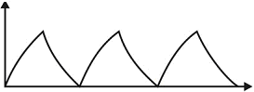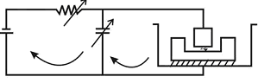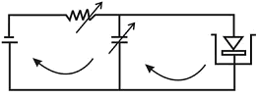
Fig.1.5 shows the basic circuit for different type of EDM generators.

1.1.9 Carbon fiber composite

Carbon fiber,alternatively graphite fiber, carbon graphite or CF, is a material consisting of extremely thin fibers about 0.005–0.010 mm in diameter and composed mostly of carbon atoms. The carbon atoms are bonded together in microscopic crystals that are more or less aligned parallel to the long axis of the fiber. The crystal alignment makes the fiber very strong for its size. Several thousand carbon fibers are twisted together to form a yarn, which may be used by itself or woven into a fabric.The properties of carbon fibers such as high flexibility, high tensile strength, low weight, high temperature tolerance and low thermal expansion make them very popular in aerospace, civil engineering, military, and motorsports, along with other competition sports. However, they are relatively expensive when compared to similar fibers for example glass fibers or plastic fibers.Carbon fibers are usually combined with other materials to form a composite. When combined with a plastic resin and wound or molded it forms carbon fiber reinforced plastic (often referred to also as carbon fiber) which is a very high strength-to-weight, extremely rigid, although somewhat brittle material. However, carbon fibers are also composed with other materials, such as with graphite to form carbon-carbon composites, which have a very high heat tolerance.

Carbon fibers are produced by using heat to chemically change rayon or acrylic fibers. Carbonization occurs at temperatures of 1000° C to 2500° C (1832° to 4532° F) in an inert atmosphere. Carbon fibers are converted to graphite at temperatures above 2500° C. Carbon and graphite fibers can also be made from pitch, a residual petroleum product. Products that use carbon fibers include heat-shielding materials, aircraft fuselages and wings, spacecraft structures, and sports equipment. High-strength fibers such as aramid (an aromatic polyamide with the commercial name Kevlar) and polyethylene are also used in armor applications such as bullet-resistant garments, car doors, and crew seats for military helicopters and aircraft.

CHAPTER-2
LITERATURE REVIEW AND PROBLEM FORMULATION 2.1 Literature Review

I.Puertas et al mentioned that during EDM machining of conductive ceramic, the main factor which effect the MRR, EW and surface finish is intensity or pulse on time. When either pulse or intensity increased, the roughness value also increased. For high values of MRR, the values of intensity, pulse time and duty cycle should be high. For low value of EW the values of intensity and pulse time should be low.

I.Puertas et al mentioned that during die sinking EDM machining the parameters which affect the MRR, EW and roughness of work surface are current and pulse time. Low values of current takes long time for process. So it is advisable to take higher values of current with low intensity, which gives better surface finish.

I.Puertas et al mentioned that the descending order of parameters which affect the MRR, current (I), voltage (V), pulse on time, duty cycle and flushing pressure. For EW the order is current (I), pulse on time and flushing pressure.

I.Puertas et al mentioned that EW tends to decrease with increase in pulse on time in case of boron carbide. But in case of silicon carbide and tungsten carbide, EW tends to increase with increase in pulse on time. EW tends to increase when duty cycle is increased in case of boron carbide and silicon carbide, but in case of tungsten carbide EW increases up to a maximum value after which it decreases. In case of MRR, its value increases with increase in duty cycle for all cases. Furthermore in case of increasing pulse time, the value of MRR is decreased.

P.M.George, B.K.Ragunath et al states that during EDM machining of carbon-carbon composite with a copper electrode, the major influencing parameters are current (I), voltage (V), pulse on time. Among all the process parameters pulse on time is insignificant. For high values of current and voltage, the value of MRR is high, but surface roundness is increased and tool wear is also increased. For low values of current and voltage, the value of MRR is decreased, but values the surface roughness and tool wear are decreased. Machining at 1amp. Current value, 20volts voltage value and 150µs pulse on time value, gives low values of EW, MRR and surface roughness. Machining at 9amp. Current value, 100volts voltage value and 750µs pulse on time value, gives high values of EW, MRR and surface roughness.

Mustafa Kurt, Eyup Bagci et al states that confirmation tests with the optimal levels of machining parameters are carried out in order to illustrate the effectiveness of the Taguchi optimization method. The validity of Taguchi's approach to process optimization is well established. Traditional experiment design procedures are too complicated and not easy to use. Taguchi method reduces the number of experiments and cost of experiments also. This method analyses the process by using the signal-to-noise ratio approach, Regression analysis and analysis of variance (ANOVA). The confirmation experiment for surface finish has shown that Taguchi design parameters can successfully verify the optimum cutting parameters.

A.A. Khan et al mentioned that during EDM machining of aluminum and mild steel with copper and brass electrodes, electrodes get more wear along their cross-section compared to its length. EW increases with increase in current and voltage. Copper electrode wear less than brass electrode because of high thermal conductivity of copper electrodes compared to brass electrode. During machining of mild steel electrode gets more wear in comparison to machining of aluminum, it is due to high thermal conductivity of aluminum compared to mild steel, so the maximum heat is dissipate into the electrode during machining of mild steel. The wear ratio increases with increase in current and gap voltage. Maximum MRR was found during machining of aluminum with brass electrode.

Y.H.Guu et al states that during EDM machining of carbon fiber reinforced carbon composite, the material gets erode in both liquid and gaseous states. The scanning micro graph shows that the resolidified particles which again adhere to the work surface are in the form of solid spheres and range from 3-30µm in diameter. Delamination of fibers can be avoided by using smaller pulse energy. While using large pulse energy high temperature is produced which causes melting of fibers and delamination of fibers. Higher pulse energy also increases surface roughness and creates a much larger recast layer. The optimal level to get high rate of material removal is at a pulse current of 5A and a pulse on time of 100 µs.
W.S.Lau et al mentioned that during machining of carbon fiber composite with copper and graphite electrodes, copper gives good surface finish and less tool wear ratio in comparison to graphite. Positive polarity should be used during machining of carbon fiber, because it gives better MRR and low tool wear ratio. The resistivity of carbon fiber is higher than copper and graphite, due to which maximum heat is produced at the work piece that causes less tool wear ratio and higher material removal rate. Low current should be used, because high current causes debonding of fibers and delamination of layers.

2.2 Problem formulation
2.2.1 Objective of present work
This works involves the optimization of parameters like (current, voltage, pulse on time and duty cycle) during EDM machining of carbon fiber composite with copper electrode by using Taguchi method.
These objectives will be considered in this work:
- To get optimal value of machining parameters like (current, voltage, pulse on time and duty cycle) for material removal rate.
- To get optimal value of machining parameters like (current, voltage, pulse on time and duty cycle) for electrode wear.
- To get optimal value of machining parameters like (current, voltage, pulse on time and duty cycle) for wear ratio.
- To get optimal value of machining parameters like (current, voltage, pulse on time and duty cycle) for surface roughness.
- Micro structure test of carbon fiber to know the effect of machining on work-piece structure.

CHAPTER-III
PARAMETRIC ANALYSIS AND DESIGN OF EXPERIMENTS

Every experimenter has to plan and conduct experiments to obtain enough and relevant data so that he can infer the science behind the observed phenomenon. He can do so by,
Trial-and-Error Approach

Performing a series of experiments each of which gives some understanding. This requires making measurements after every experiment so that analysis of observed data will allow him to decide what to do next - "Which parameters should be varied and by how much". Many a times such series does not progress much as negative results may discourage or will not allow a selection of parameters which ought to be changed in the next experiment. Therefore, such experimentation usually ends well before the numbers of experiments reach a double digit! The data is insufficient to draw any significant conclusions and the main problem (of understanding the science) still remains unsolved.
3.1 Design of Experiments

A well planned set of experiments, in which all parameters of interest are varied over a specified range, is a much better approach to obtain systematic data. Mathematically speaking, such a complete set of experiments ought to give desired results. Usually the number of experiments and resources (materials and time) required are prohibitively large. Often the experimenter decides to perform a subset of the complete set of experiments to save on time and money! However, it does not easily lend itself to understanding of science behind the phenomenon. The analysis is not very easy (though it may be easy for the mathematician/statistician) and thus effects of various parameters on the observed data are not readily apparent. In many cases, particularly those in which some optimization is required, the method does not point to the best settings of parameters. A classic example illustrating the drawback of design of experiments is found in the planning of a world cup event, say football. While all matches are well arranged with respect to the different teams and different venues on different dates and yet the planning does not care about the result of any match (win or lose)!!!! Obviously, such a strategy is not desirable for conducting scientific experiments (except for co-ordinating various institutions, committees, people, equipment, materials etc.).
3.1.1 Various Design of Experiment Techniques

There are following techniques used in Design of Experiments:
- Taguchi
- Factorial design: There are following method have been used:
  - Experiments with single factors: The Analysis of variance
  - Two-Level fractional factorial designs
  - Three Level and Mixed Level factorial and fractional
- Response surface method
- Fitting Regression Models
For the present work it should be mentioned only Taugchi method.
3.2 Taguchi Method

Taguchi Method, pioneered by Dr. Genichi Taguchi, greatly improves engineering productivity. The Taguchi method seeks to minimize the effects of noise and to determine the optimum level of important controllable factors based on the concept of robustness.
Its advocates the three-stage design operation to determine the target values and tolerance for relevant parameters in the product and the process:
a. System design
b. Parameter design
c. Tolerance design
Dr. Taguchi of Nippon Telephones and Telegraph Company, Japan has developed a method based on “ORTHOGONAL ARRAY” experiments which gives much reduced “variance” for the experiment with “optimum settings” of control parameters. Thus the marriage of Design of Experiments with optimization of control parameters to obtain BEST results is achieved in the Taguchi Method. "Orthogonal Arrays" (OA) provide a set of well balanced (minimum) experiments.
Signal-to-Noise ratios (S/N), which are log functions of desired output, serve as objective functions for optimization, help in data analysis and prediction of optimum results.

3.2.1 Taguchi Method Treats Optimization Problems in Two Categories

3.2.1.1 Static Problem

Generally, a process to be optimized has several control factors which directly decide the target or desired value of the output. The optimization then involves determining the best control factor levels so that the output is at the target value. Such a problem is called as a "STATIC PROBLEM".

CONTROL FACTORS
Z

P-DIAGRAM
NOISE
X
OUTPUT
Y

Fig 3.1: showsP-Diagram for Static Problem.

Primary aim of the Taguchi experiments to minimize variations in output even though noise is present in the process. This is best explained using a P-Diagram which is shown below ("P" stands for Process or Product). Noise is shown to be present in the process but should have no effect on the output! This process is then said a static problem.
3.2.1.2 Dynamic Problem

If the product to be optimized has a signal input that directly decides the output, the optimization involves determining the best control factor levels so that the "input signal / output" ratio is closest to the desired relationship. Such a problem is called as a “DYNAMIC PROBLEM”.

CONTROL FACTORS
Z

P-DIAGRAM
NOISE
X
SIGNAL
M
OUTPUT
Y
Fig 3.2 :shows P-Diagram for Dynamic Problem

This is best explained by a P-Diagram which is shown below. Again, the primary aim of the Taguchi experiments - to minimize variations in output even though noise is present in the process- is achieved by getting improved linearity in the input/output relationship.
3.3 Signal to Noise (S/N) Ratio

The S/N ratio as stated earlier, is a concurrent statistic. A concurrent statistic is able to look at two characteristics of a distribution and roll these characteristics into a single number of figures of merits. The S/N ratio combines both the parameters (the mean level of quality characteristic and variance around this mean) into a single metric. The S/N ratio several consolidates repetitions (at least two data points are required) into one value. The second approach, which Taguchi strongly recommends, is to use signal-to-noise (S/N) ratio for the same steps in the analysis by maximizing the S/N ratio. The loss associated can be minimized.
3.3.1 Static Problem (Batch Process Optimization)

There are 3 Signal-to-Noise ratios of common interest for optimization of Static Problems;
(1) Smaller-The-Better:
S/N_{SB} = −10 Log₁₀ [mean of sum of squares of measured data]
OR
S/N_{SB}= −10 Log₁₀ ( y_{i}²)
This is usually the chosen S/N ratio for all undesirable characteristics like “defects" etc. for which the ideal value is zero. Also, when an ideal value is finite and its maximum or minimum value is defined (like maximum purity is 100% or maximum T_{c} is 92K or minimum time for making a telephone connection is 1 sec) then the difference between measured data and ideal value is expected to be as small as possible. The generic form of S/N ratio then becomes,
S/N_{SB} = -10 Log₁₀ [mean of sum of squares of {measured - ideal}]
(2) Larger-The-Better S/N_{LB} = -10 Log₁₀[mean of sum squares of reciprocal of measured data]
OR
S/N_{LB}= −10 Log₁₀ ( 1/ y_{i}²) This case has been converted in to LARGER-THE-BETTER by taking the reciprocal of measured data and then taking the S/N ratio as in the smaller the-better.
(3) Nominal-The-Best
S/N_{NB} = 10 Log₁₀ [Square of mean/ Variance]
OR S/N_{NB} =−10 Log₁₀ V_{e}
This case arises when a specified value is MOST desired, meaning that neither a smaller nor a larger value is desirable.
Examples; (i) Most parts in mechanical fittings have dimensions which are nominal-the-best type.
(ii) Ratios of chemicals or mixtures are nominally the best type.
(iii) Thickness should be uniform in deposition /growth /plating /etching.
3.3.2DynamicProblem (Technology Development) In dynamic problems, we come across many applications where the output is supposed to follow input signal in a predetermined manner. Generally, a linear relationship between “input” “output” is desirable.
For example: Accelerator peddles in cars, volume control in audio amplifiers document copier (with magnification or reduction) various types of moldings etc.
There are 2 characteristics of common interest in "follow-the-leader" or "Transformations" type of applications, (i) Slope of the I/O characteristics (ii) Linearity of the I/O characteristics (minimum deviation from the best-fit straight line)
3.3.3 Sensitivity {Slope} The slope of I/O characteristics should be at the specified value (usually 1).
- It is often treated as Larger-The-Better when the output is a desirable characteristics (as in the case of Sensors, where the slope indicates the sensitivity).
n = 10 Log₁₀ [square of slope or beta of the I/O characteristics]
- On the other hand, when the output is an undesired characteristic, it can be treated as Smaller-the-Better.
n = -10 Log₁₀ [square of slope or beta of the I/O characteristics]
3.4.4 Linearity (Larger-The-Better) Most dynamic characteristics are required to have direct proportionality between the input and output. These applications are therefore called as "TRANSFORMATIONS". The straight line relationship between I/O must be truly linear i.e. with as little deviations from the straight line as possible.
n=10Log₁₀[Square of slope or beta/Variance]
Variance in this case is the mean of the sum of squares of deviations of measured data points from the best-fit straight line (linear regression).
3.4 Steps in Taguchi Methodology Taguchi method is a scientifically disciplined mechanism for evaluating and implementing improvements in products, processes, materials, equipment, and facilities. These improvements are aimed at improving the desired characteristics and simultaneously reducing the number of defects by studying the key variables controlling the process and optimizing the procedures or design to yield the best results. The method is applicable over a wide range of engineering fields that include processes that manufacture raw materials, sub systems, products for professional and consumer markets. In fact, the method can be applied to any process be it engineering fabrication, computer-aided-design, banking and service sectors etc. Taguchi method is useful for 'tuning' a given process for ‘best’ results.Taguchi proposed a standard 8-step procedure for applying his method for optimizing any process.
3.4.1 Eight Steps in Taguchi Methodology
Step1: Identify the main function, side effects, and failure mode. Step2: Identify the noise factors, testing Conditions, and quality characteristics. Step3: Identify the objective function to be optimized. Step-4: Identify the control factors and their levels. Step-5: Select the orthogonal arrays matrix. Step-6: Conduct the matrix experiments. Step-7: Analyze the data; predict the optimum levels and performance. Step-8: Perform the verification experiment and plan the future action.
  - Experimental Design Strategy
Taguchi recommends orthogonal arrays (OA) for lying out of experiments. To design an experiment is to select the most suitable OA and to assign the parameters and interactions to the appropriate columns. Studying the main effects of each of the parameters identifies the optimum condition. The main effect indicates the general trends of influence of each parameter. The knowledge of contribution of individual parameters is a key in deciding the natures of control to be established on a production process. The analysis of variance (ANOVA) is the statistical treatment most commonly applied to the results of the experiments in determining the percent contribution of each parameter against a stated level of confidence. Robust Design focuses on improving the fundamental function of the product or process, thus facilitating flexible designs and concurrent engineering. Indeed, it is the most powerful method available to reduce product cost, improve quality, and simultaneously reduce development interval.
The robustness Strategy uses five primary tools: 1. P-Diagram is used to classify the variables associated with the product into noise, control, signal (input), and response (output) factors. 2. Ideal Function is used to mathematically specify the ideal form of the signal-response relationship as embodied by the design concept for making the higher-level system work perfectly. 3. Quadratic Loss Function (also known as Quality Loss Function) is used to quantify the loss incurred by the user due to deviation from target performance. 4. Signal-to-Noise Ratio is used for predicting the field quality through laboratory experiments. 5. Orthogonal Arrays are used for gathering dependable information about control factors (Design parameters) with a small number of experiments.

3.5.1 Parameter Diagram:
Fig: 3.3 shows the parameter diagram for product/process/system.
Noise Factor X
Control Factor Z
Input
X
Output
Y
Product
Process
System

3.5.2 Quality Measurement
Let us define the following variables:
m: target value for a critical product characteristic
+/- .0: allowed deviation from the target
A0: loss due to a defective product
Then the quality loss, L, suffered by an average customer due to a product with y as value of the characteristic is given by the following equation:
L = k * (y - m)²
Where k = (A₀ / Δ₀²)
If the output of the factory has distribution of the critical characteristic with mean Δ. and variance Δ² , then the average quality loss per unit of the product is given by:
Q = k {(Δ - m) 2 + Δ²}
Taguchi suggest two different routes to carry out the complete analysis. First the standard approach, where the results of a single run or the average of the respective runs are processed through main effect and ANOVA analysis. The second approach, which Taguchi strongly recommends, is to use signal-to-noise (S/N) ratio for the same steps in the analysis by maximizing the S/N ratio. The loss associated can be minimized.
  - Steps in Experimental Design and Analysis

The Taguchi experimental design and analysis is presented following sector:
    - Selection of Orthogonal Array (OA)

In selection an appropriate OA the pre-requisites are:
(1) Selection of process parameters and/or interactions to be evaluated.
(2) Selection of number of levels for the selected parameters.
The total degree of freedom (DOF) of an experiment is a direct function of total number of trails. If the number of levels of parameters increases, the DOF of the parameter also increases because the DOF of a parameter is the number of levels minus one. Thus, two levels for each parameter are recommended to minimize the size of the experiment.
The basic kinds of OA developed by Taguchi are either two-level arrays or three-level arrays.
The standard two-level and three-level arrays are:
I. Two-level arrays: L4, L8, L12, L16, L32
II. Three-level arrays: L9, L18, L27
The number in the array designation indicates the number of trials in that array. The total degree of freedom () available in an OA is equal to the number of trials minus one:
F_{1N} = N-1
F_{1N} = total degree of freedom of an OA
L_{N}= OA designation
N=number of trials When a particular array is selected for an experiment the following inequality must be satisfied:
F_{1N}>= Total DOF required for parameters and interactions
3.6.2 Assignment of Parameters and Interactions to the OA

The OA have several columns available for assignment of parameters and some columns subsequently can estimate the effect of interactions of these parameters. Taguchi has provided two tools to aid in the assignment of parameters and interactions to arrays:
(1) Linear Graphs
(2) Triangular Tables

3.6.3 Experiment and data analysis

The experiment is conducted against each of the trial conditions of the inner array. Each experiment at the trial condition is repeated simply (without using any outer array).Randomization strategies should be considered during the experiment. The data (raw data) are recorded against each trial condition and S/N ratios of the repeated data points are calculated and recorded against each trial condition.
3.6.4 Data Analysis

A number of methods have been suggested by Taguchi for analyzing the data: observation method, ranking method, column effects, ANOVA, S/N ANOVA, plot of average response curves; interactions graphs etc. However in the present investigation the following method have been used:
- Plot of average response curve
- ANOVA for raw data
- ANOVA for S/N data
3.6.5 Parametric Design Strategy
- Parameters Classification and Selection of Optimal levels
- Prediction of the mean
- Determination of Confidence Interval
- Confirmation Experiment

3.7 DESIGN OF EXPERIMENTS
A well planned set of experiments, in which all parameters of interest are varied over a specified range, is a much better approach to obtain systematic data. Mathematically speaking, such a complete set of experiments ought to give desired results.
Various design of experiment techniques: There are following techniques used for design of experiments
- Taguchi
- Factorial Design
- Response Surface Method (RSM)
- Fitting Regression Models
Full Factorial Design method is used in the present work.
6.1.1 FULL FACTORIAL DESIGN
Full factorial is most common and most intuitive strategy of experimental design. In most simple form, the two level full factorial. There are two factors and two levels for each factor. The samples are given by every possible combination of the factors values. In the present example number of factors is 2 and level for each factor is 2 so that by full factorial design method there exist 2² combinations or we can say that total 4 experiments have to be performed to study the effect of each factor on the response variable, as well as the effects of interactions between factors on the response variable.
A full factorial design of experiments consists of the following:
1. Vary one factor at a time
2. Perform experiments for all levels of all factors
3. Hence perform a large number of experiments that are needed
Let the number of factors = k
Let the number of levels for the i^{th} factor = n_{i}
The total number of experiments (n) that need to be performed is =
In the present work we are having total 4 factors with 3 levels for each.
Number of factors (k) = 4
Number of levels (n) = 3
Total number of combinations = Number of levels ^{number of factors} (n^{k})
On putting the values of n=3 and k=4 then 3⁴ possible combinations are obtained it means that we have to perform 3×3×3×3=81 experiments to study the effect of each factor on the response variable.
Full factorial design can be performed with the help of MINITAB 17 software having following steps.
Step 1: Inputting the Data
Open the Minitab worksheet file by clicking File →Open Worksheet; select the file Click Open key. You may see a popup window with message “a copy of the content of this file will be added to the current project.” Click OK. Then you will see the data of the experiment in the worksheet.
Step 2: Defining the Factorial Design.
Click Stat →DOE → Factorial → Define Custom Factorial Design. In the pop-up dialogue box, select three input factors by double clicking all three factors for Factors as shown below
Step 3: Analyzing the factorial design
After define the factorial design, perform the analysis by clicking Stat → DOE → Factorial →Analyze Factorial Design. In the pop-up window, double click for Responses. In the pop-up window, click the key “Terms” and set the maximum order for terms in the model as “3”.
Step 4: Finding significant factors and re-analyzing the design after analyzing factorial design draw the factorial plots by clicking Stat → DOE → Factorial→ Factorial plot. According to the factorial plots of the standardized effects, factors I, Ton and RPM have significant effect on the responses.

Table: 3.1 shows L27 orthogonal array series:
Row | Peak A | Ton | Toff | Weight Before (gm) | Weight After (gm) | Weight Reduced (gm) | MRR (mg/min)
1 | 1.5 | 30 | 30 | 50.7478 | 50.742746 | 0.005054 | 0.336933
2 | 3 | 30 | 30 | 50.742746 | 50.732771 | 0.009975 | 0.665
3 | 4.5 | 30 | 30 | 50.732771 | 50.717875 | 0.014896 | 0.993067
4 | 1.5 | 30 | 15 | 50.717875 | 50.698058 | 0.019817 | 1.321133
5 | 3 | 30 | 15 | 50.698058 | 50.67332 | 0.024738 | 1.6492
6 | 4.5 | 30 | 15 | 50.67332 | 50.643661 | 0.029659 | 1.977267
7 | 1.5 | 30 | 8 | 50.643661 | 50.609081 | 0.03458 | 2.305333
8 | 3 | 30 | 8 | 50.609081 | 50.56958 | 0.039501 | 2.6334
9 | 4.5 | 30 | 8 | 50.56958 | 50.525158 | 0.044422 | 2.961467
10 | 1.5 | 60 | 30 | 50.525158 | 50.475815 | 0.049343 | 3.289533
11 | 3 | 60 | 30 | 50.475815 | 50.421551 | 0.054264 | 3.6176
12 | 4.5 | 60 | 30 | 50.421551 | 50.362366 | 0.059185 | 3.945667
13 | 1.5 | 60 | 15 | 50.362366 | 50.29826 | 0.064106 | 4.273733
14 | 3 | 60 | 15 | 50.29826 | 50.229233 | 0.069027 | 4.6018
15 | 4.5 | 60 | 15 | 50.229233 | 50.155285 | 0.073948 | 4.929867
16 | 1.5 | 60 | 8 | 50.155285 | 50.076416 | 0.078869 | 5.257933
17 | 3 | 60 | 8 | 50.076416 | 49.992626 | 0.08379 | 5.586
18 | 4.5 | 60 | 8 | 49.992626 | 49.903915 | 0.088711 | 5.914067
19 | 1.5 | 90 | 30 | 49.903915 | 49.810283 | 0.093632 | 6.242133
20 | 3 | 90 | 30 | 49.810283 | 49.71173 | 0.098553 | 6.5702
21 | 4.5 | 90 | 30 | 49.71173 | 49.608256 | 0.103474 | 6.898267
22 | 1.5 | 90 | 15 | 49.608256 | 49.499861 | 0.108395 | 7.226333
23 | 3 | 90 | 15 | 49.499861 | 49.386545 | 0.113316 | 7.5544
24 | 4.5 | 90 | 15 | 49.386545 | 49.268308 | 0.118237 | 7.882467
25 | 1.5 | 90 | 8 | 49.268308 | 49.14515 | 0.123158 | 8.210533
26 | 3 | 90 | 8 | 49.14515 | 49.017071 | 0.128079 | 8.5386
27 | 4.5 | 90 | 8 | 49.017071 | 48.884071 | 0.133 | 8.866667

  - Parametric Analysis
Machining Parameters are selected by further study of various experimental based research papers. Parameters are selected in decreasing order of influencing the machining characteristics like (material removal rate, tool wear, surface roughness, and microstructure of work-piece).
Selected variable parameters with their ranges are given below:-
- Pulse current------------------------------------------ 1-5 Amp.
- Gap voltage------------------------------------------- 20-60 Volts.
- Pulse on time----------------------------------------- 50-100 μs
- Duty cycle--------------------------------------------- 0.4-0.6
S.No | Variable Parameters | Level 1 | Level 2 | Level 3
1. | Pulse current (Amp) | 1.5 | 3 | 4.5
2. | Pulse off time (μs) | 8 | 15 | 30
3. | Pulse on time (μs) | 30 | 60 | 90

Table: 3.2 shows three levels of variable parameters.

These variable parameters are selected in decreasing order of influencing machining characteristic. Current affects the machining characteristic mainly, the next parameter which affect the machining characteristic is gap voltage, other parameters are pulse on time and duty cycle. Parameters are selected in two forms (1) Variable parameters (2) Desired machining characteristics. This work is based on the study of variable machining parameters and their effect on machining characteristics.
Desired machining characteristics are given here:
- Material removal rate
- Surface roughness
- Microstructure of work-piece
These machining characteristics are examined at different variable parameter. Experiments have done on different values of variable parameters to obtain the effect of these parameters on machining characteristics.
    - Material selection for work-piece and tool

EDM machine has a limitation for material selection, that work-piece and tool both should be conductive, otherwise machining can not perform. There is a wide range of material to select as work-piece or tool, but due to the limitation of EDM machine, material selection is being limited around the conductive material. There is also a wide range of conductive material, then the next criteria to select the material is, utility of that material for engineering purpose. There are so many advancement in engineering materials. Now a day’s several new materials have been developed like ceramics, composites, Fibers, etc.This work is based on carbon fiber composite material machining. Composite Material, substance that is made up of a combination of two or more different materials. A composite material can provide superior and unique mechanical and physical properties because it combines the most desirable properties of its constituents while suppressing their least desirable properties. For example, a glass-fiber reinforced plastic combines the high strength of thin glass fibers with the ductility and chemical resistance of plastic; the brittleness that the glass fibers have when isolated is not a characteristic of the composite. The opportunity to develop superior products for aerospace, automotive, and recreational applications has sustained the interest in advanced composites. Currently composites are being considered on a broader basis—for applications that include civil engineering structures such as bridges and freeway pillar reinforcement; and for biomedical products, such as prosthetic devices. Composite materials usually consist of synthetic fibers embedded within a matrix, a material that surrounds and is tightly bound to the fibers. The most widely used type of composite material is polymer matrix composites (PMCs). PMCs consist of fibers made of a ceramic material such as carbon or glass embedded in a plastic matrix. Typically, the fibers make up about 60 percent of a polymer matrix composite by volume. Metal matrices or ceramic matrices can be substituted for the plastic matrix to provide more specialized composite systems called metal matrix composites (MMCs) and ceramic matrix composites (CMCs), respectively. The fibrous reinforcing constituent of composites may consist of thin continuous fibers or relatively short fiber segments. When using short fiber segments, however, fibers with a high aspect ratio (length-to-diameter ratio) are used. Continuous-fiber composites are generally required for high performance structural applications. The specific strength (strength-to-density ratio) and specific stiffness (elastic modulus-to-density ratio) of continuous carbon fiber PMCs, for example, can be vastly superior to conventional metal alloys. Composites can also have other attractive properties, such as high thermal or electrical conductivity, and a low coefficient of thermal expansion. Also, depending on how the fibers are oriented or interwoven within the matrix, composites can be fabricated that have structural properties specifically tailored for a particular structural use. Although composite materials have certain advantages over conventional materials, composites also have some disadvantages. For example, PMCs and other composite materials tend to be highly anisotropic—that is, their strength, stiffness, and other engineering properties are different depending on the orientation of the composite material. For example, if a PMC is fabricated so that all the fibers are lined up parallel to one another, then the PMC will be very stiff in the direction parallel to the fibers, but not stiff in the perpendicular direction. These anisotropic properties pose a significant challenge for the designer who uses composite materials in structures that place multidirectional forces on the structural members. Also, forming strong connections between separate composite material components is difficult.
Carbon and graphite fibers are high-strength materials that are used as reinforcing agents in composites.
For tool material copper (99.5%) is used. Copper is selected as a tool material, because of its higher conductive over other conductive material.

    - Properties of work-piece and tool material

The material used for this work is carbon fiber composite developed from carbon fiber cloth of 0.2mm thickness. Resin is used as a bonding material. Phenolic resin (Code LY 556) is used for laminate the carbon fiber cloth’s layers. These layers are kept over another, and then these overlapped fiber cloth layers are pressed under cure of a particular pressure and temperature. The resistivity of the material is 57×10⁻³ cm. Density of the material is 1850 kg/m³.

Work Electrical Type of Density Volume fraction Fiber
Material Resistivity resin of carbon Diameter
(cm) (kg/m³) (%) (μm)
Carbon 87×10⁻³ LY-556 1850 70 7.45 Fiber composite

Table: 3.3 properties of work-piece material

Tool Electrical Melting Thermal Specific heat Density
Material Resistivity Point Conductivity Capacity
(cm) ( °C ) (W/m-°K) (J/g-°C) (kg/m³)
Copper 1.6 1083 391 0.39 8930

Table: 3.3 properties of tool material

CHAPTER-IV
EXPERIMENTAL SETUP, RESULT, AND ANALYSIS
4.1 Experimental setup
Experiments are per formed on a die-sinking EDM machine of model AgieCharmilles FORM E 350 manufactured by GF+ Machining Solutions.
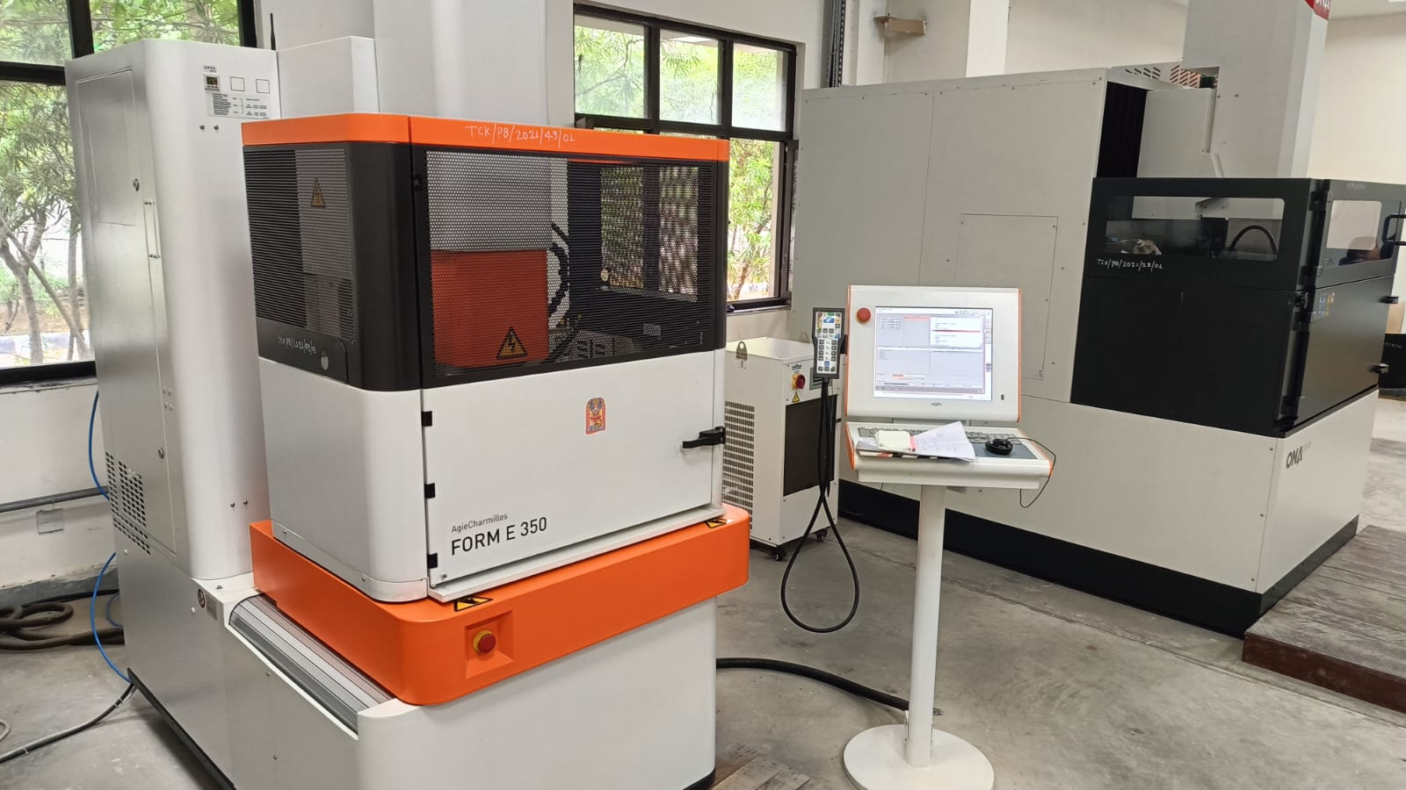

Fig 4.1: Shows Die sinking EDM machine used.

Machines specifications are as given here-:
Load Capacity: 500 Kgs, Working Surface: 350×250×250mm
Axis Travel: 350×250×250mm
Built-in super finishing and EZY-logic (Fuzzy) for auto-parameter selection.
Pulse generator type: MOSFET
Maximum working current: 80A
Impulse Voltage: 250V
Pulse on time: 0.5 to 1500 µ sec
Pulse frequency: 1 to 500 KHz
Max. MRR: 450 mm³ /min.
Best Surface finishes: 0.1 µ Ra
Min. electrode wears : <0.1%
Power supply: 3 phase, 400 V, 50 Hz
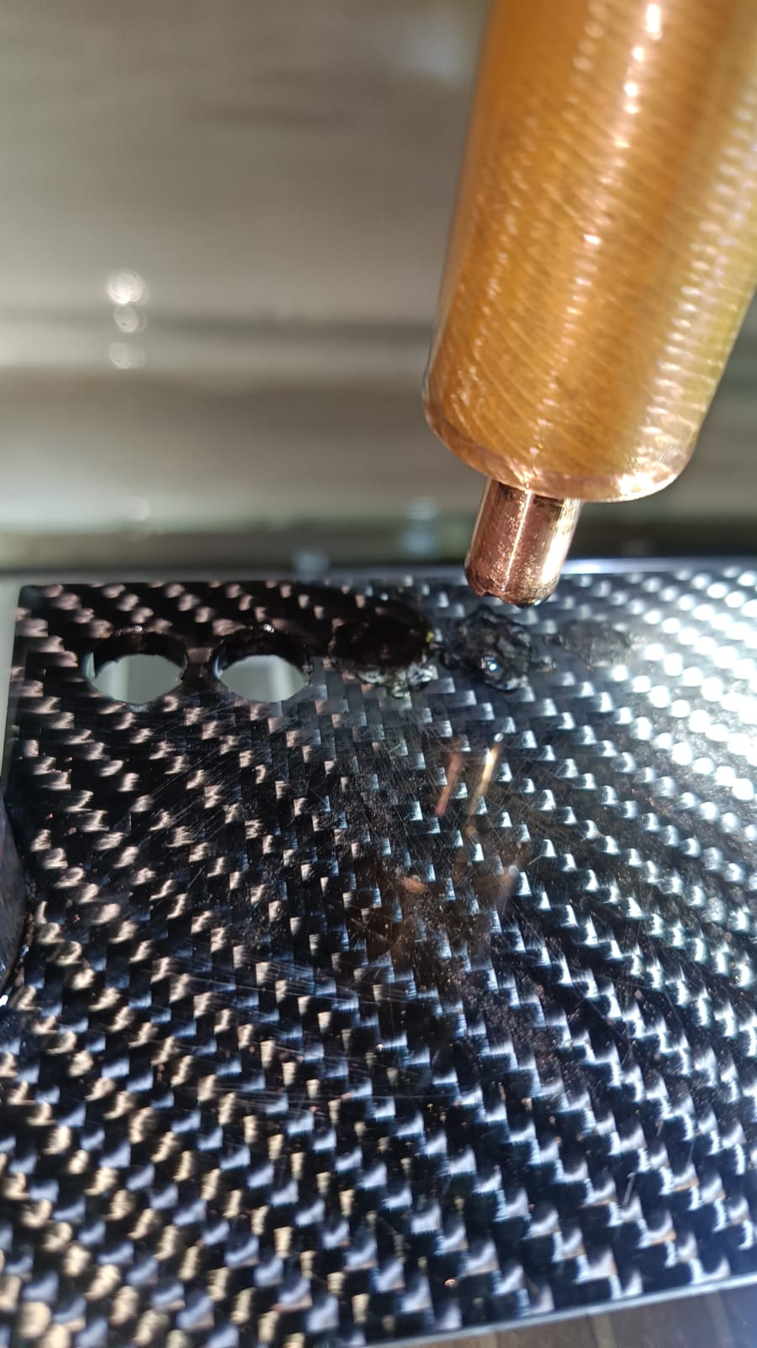Connected load: 5 KVA

Fig4.2: shows arrangement of work-piece and electrode on machine.

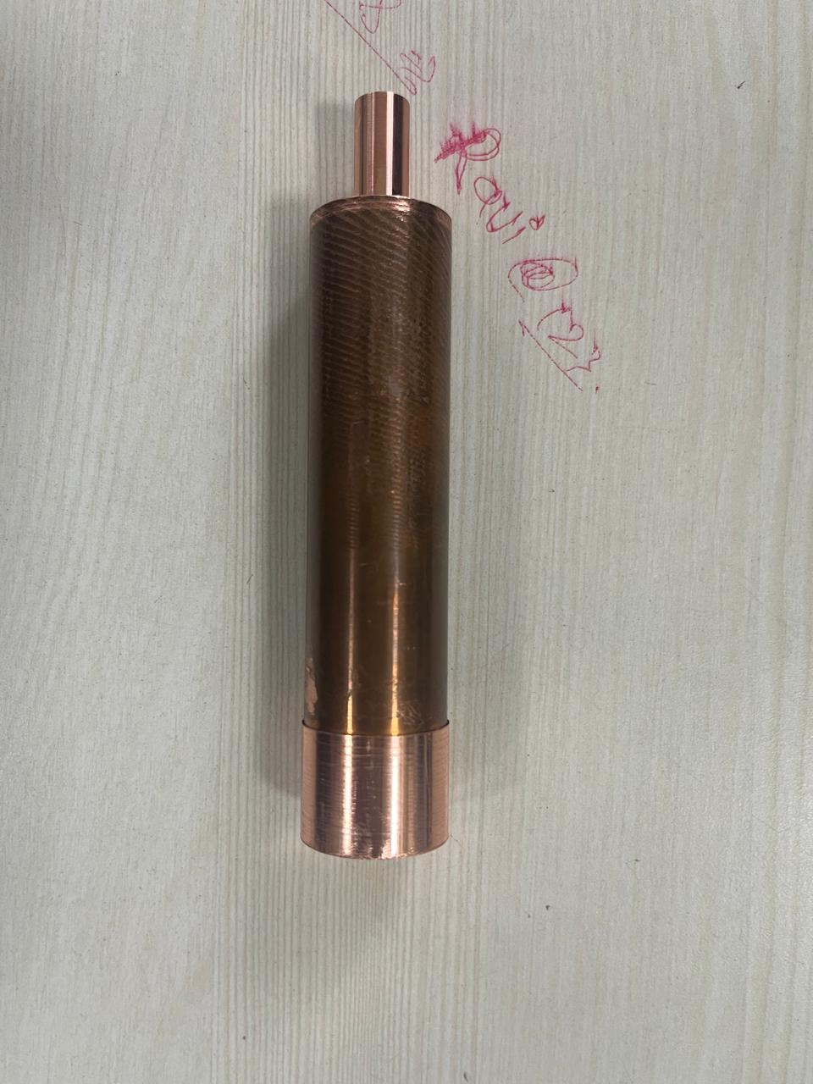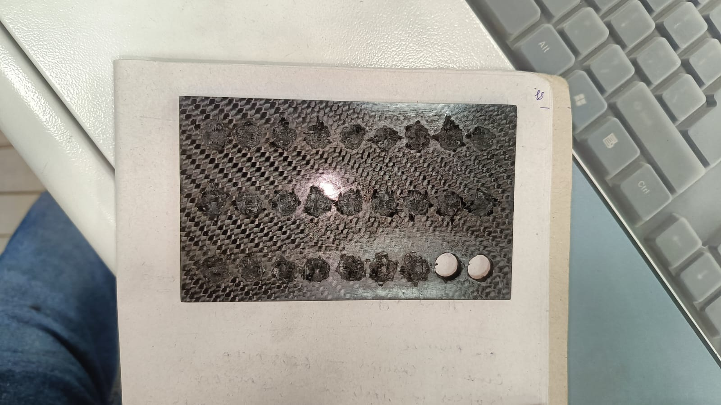

Fig 4.3:.shows Electrode after machining Fig 4.4: shows Work-piece after
machining

4.2 Result and analysis:
4.2.1 Calculation of material removal rate (MRR):

Material removal is calculated by taking the difference between weight of work-piece material before and after machining. Material removal rate is calculated by dividing material removal by machining time.
Material removal rate =

4.2.1.1 Calculation of S/N ratio for material removal rate:
The S/N ratio, which condenses the multiple data points with in a trial, depends on the type of characteristic being evaluated. For calculation of S/N ratio for material removal rate LARGER-THE-BETTER conditition is opted. The equation for calculation of S/N ratio for material removal rate is:-
S/N_{LB}= −10 Log₁₀ ( 1/ y_{i}²)
Where n = number of tests in a trial (number of repetitions regardless of noise levels).
Yi = measured value of response (in this case response is MRR).

4.2.1.2 Calculation of Mean S/N Ratio for material removal rate:
The calculation of mean (S/N) ratio is done with the help of following relation;
n_{fi =} (n_{fi1 +} n_{fi2 +} n_{fi3) / 3}
Where, n_{fi =} mean (S/N) ratio for factor f at the level value i of the selected factor. n_{fi1,} n_{fi2,} n_{fi3} = (S/N) ratios for factor f at level i.
By going through above calculation, following mean (S/N) ratio table will get.
Table 4.7: shows the value of mean (S/N) ratio for different factors at 1, 2, 3 level.
This table shows rank of factors and factors affect the machining characteristic in that order. In above response table, current shows main response, the next main response is shows by voltage. Duty cycle shows response at third position, and pulse on time is less responsible for machining characteristic in comparison to other factors. Delta is calculated by taking difference between higher and lowers S/N ratio values for each factor. According to these values of delta, rank is decided. In above table current shows first rank, because delta value for current factor is higher than other factors.
In above response table higher values of S/N ratios of each factor shows the optimal level of that factor.
4.2.1.3Regression analysis:
4.2.1.5 Optimun level:
Factor effect plot for MRR

Table 4.10: shows optimum level of MRR
Figure shows effects of variables on material removal rate. Current at level 1 shows low material removal rate and at level 3 it gives high material removal rate. At level 1 & 2 MRR value is below the overall mean value, when current value changes from level 2 to 3, MRR value increases above the overall mean value. In case of voltage, at level 1 & 2, MRR value is below the overall mean value, when voltage value changes from level 2 to 3, MRR values increase above the overall mean value. At level 1 of pulse on time MRR value is above the overall mean value, when its value changes from level 1 to 2, MRR value increases, but when its value changes from level 2 to 3, MRR value decreases. In case of duty cycle, when its value changes from level 1 to 2, MRR value decreases and when its value changes from level 2 to 3 its value again decreases.
The S/N ratio, which condenses the multiple data points with in a trial, depends on the type of characteristic being evaluated. For calculation of S/N ratio for tool wear rate SMALLER THE BETTER condition is opted. The equation for calculation of S/N ratio for tool wear rate is:-
S/N_{SB}= −10 Log₁₀ ( y_{i}²)
Where n = number of tests in a trial (number of repetitions regardless of noise levels).
Response Table for Signal to Noise ratios:
This table shows rank of factors and factors affect the machining characteristic in that order. In above response table, current shows main response. The next main response is shows by voltage. Duty cycle shows response at third position, and pulse on time is less responsible for machining characteristic in comparison to other factors. Delta is calculated by taking difference between higher and lowers S/N ratio values for each factor. According to these values of delta, rank is decided. In above table current shows first rank, because delta value for current factor is higher than other factors.
In above response table higher values of S/N ratios of each factor shows the optimal level of that factor.

4.2.2.3 Regression analysis
The regression equation for TWR is:
TWR = − 0.000037 + 0.000081 Ip + 0.000002 Vg - 0.000001 Ton - 0.000077 η
Table 4.13: shows regression analysis of TWR
S = 0.0000524607 R-Sq = 93.9% R-Sq (adj) = 87.9

Fig 4.8: shows effect of control factors and their levels on TWR.

4.2.2.6 Optimum levels for TWR:
Process variables or Factors Optimum Levels
Pulse current I_{P1} 1 Amp.
Gap voltage V_{g1} 20 Volts
Pulse on time T_{ON1} 50 μs
Duty cycle η₁ 0.4
Table 4.15: shows optimum level of TWR

Figure shows effects of variables on tool wear rate. Current at level 1 shows low tool wear rate and at level 3 it gives high tool wear rate. At level 2 & 3 TWR value is below the overall mean value, when current value changes from level 2 to 3, TWR value increases. In case of voltage, at level 2 & 3, TWR value is below the overall mean value, when voltage value changes from level 2 to 3, TWR values increase. At level 1 of pulse on time TWR value is above the overall mean value, when its value changes from level 1 to 2, TWR value increases, but when its value changes from level 2 to 3, TWR value decreases. In case of duty cycle, when its value changes from level 1 to 2, TWR value increases and when its value changes from level 2 to 3, TWR value decreases.

Where n = number of tests in a trial (number of repetitions regardless of noise levels).
Yi = measured value of response (in this case response is WR).

4.2.3.2 Calculation of Mean S/N Ratio for WR
The calculation of mean (S/N) ratio is done with the help of following relation;
n_{fi =} (n_{fi1 +} n_{fi2 +} n_{fi3) / 3}
Where, n_{fi =} mean (S/N) ratio for factor f at the level value i of the selected factor. n_{fi1,} n_{fi2,} n_{fi3} = (S/N) ratios for factor f at level i.
By going through above calculation, following mean (S/N) ratio table will get;
This table shows rank of factors and factors affect the machining characteristic in that order. In above response table, current shows main response. The next main response is shows by voltage. Duty cycle shows response at third position, and pulse on time is less responsible for machining characteristic in comparison to other factors. Delta is calculated by taking difference between higher and lowers S/N ratio values for each factor. According to these values of delta, rank is decided. In above table current shows first rank, because delta value for current factor is higher than other factors.
In above response table higher values of S/N ratios of each factor shows the optimal level of that factor.

Table 4.19:shows regression analysis
S = 0.0220983 R-Sq = 95.2% R-Sq (adj) = 90.4

4.2.3.4 Analysis of variance:

Source DF SS MS F P

Regression 4 0.0389026 0.0097257 19.92 0.007
Residual Error 4 0.0019533 0.0004883
Total 8 0.0408560
Table 4.20: shows regression analysis
4.2.4.1 Calculation of S/N ratio for surface roughness:
The S/N ratio, which condenses the multiple data points with in a trial, depends on the type of characteristic being evaluated. For calculation of S/N ratio for surface roughness SMALLER THE BETTER conditition is opted. The equation for calculation of S/N ratio for tool wear rate is:-
S/N_{SB}= −10 Log₁₀ ( y_{i}²)
Where n = number of tests in a trial (number of repetitions regardless of noise levels).
Yi = measured value of response (in this case response is SR)
4.2.4.2 Calculation of Mean S/N Ratio for SR
The calculation of mean (S/N) ratio is done with the help of following relation;
n_{fi =} (n_{fi1 +} n_{fi2 +} n_{fi3) / 3}
Where, n_{fi =} mean (S/N) ratio for factor f at the level value i of the selected factor. n_{fi1,} n_{fi2,} n_{fi3} = (S/N) ratios for factor f at level i.
By going through above calculation, following mean (S/N) ratio table will
This table shows rank of factors and factors affect the machining characteristic in that order. In above response table, current shows main response. The next main response is shows by voltage. Duty cycle shows response at third position, and pulse on time is less responsible for machining characteristic in comparison to other factors. Delta is calculated by taking difference between higher and lowers S/N ratio values for each factor. According to these values of delta, rank is decided. In above table current shows first rank, because delta value for current factor is higher than other factors.
In above response table higher values of S/N ratios of each factor shows the optimal level of that factor.

4.2.4.3 Regression analysis
The regression equation for SR is:
SR = 2.94 + 1.19 Ip + 0.0332 Vg - 0.00380 Ton - 0.933 η

4.2.4.5 Optimum level:
Factor effect plot for SR
Fig 4.10: shows effect of control factors and their levels

4.2.4.6 Optimum levels for SR:
Process variables or Factors Optimum Levels
Pulse current I_{P1} 1 Amp.
Gap voltage V_{g1} 20 Volts
Pulse on time T_{ON2} 75 μs
Duty cycle η₁ 0.4
Table 4.26: shows optimum level of SR

Figure shows effects of variables on surface roughness. Current at level 1 shows good surface finish and at level 3, surface finish becomes rough. At level 2 & 3, SR value is below the over all mean value, when current value changes from level 2 to 3, SR value increases (it means surface becomes rough). In case of voltage, at level 3, SR value is below the overall mean value, when voltage value changes from level 2 to 3, SR values increase. At level 1 of pulse on time, SR value is equal to the over all mean value, when its value changes from level 1 to 2, SR value decreases, because increased value of pulse on time erode material equally from the surface of work-piece and gives a good surface finish, but when its value changes from level 2 to 3, SR value increases, because material removal becomes unequal due to increase in pulse on time. In case of duty cycle, when its value changes from level 1 to 2, SR value increases and when its value changes from level 2 to 3, SR value decreases.

